* Created Schema `data-1202-final_project`

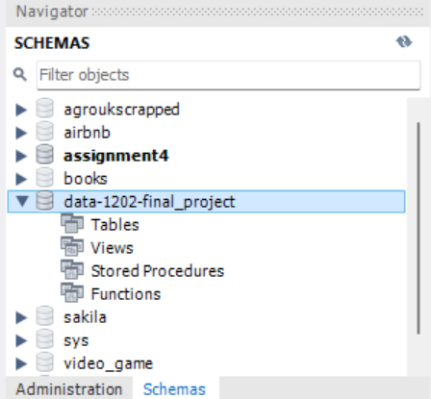

* Clean data by dividing Blood_Pressure to Upper_Blood_Pressure and Lower_Blood_Pressure in excel.

* Load both CSV file in dataset to fact and dim table of MySQL

* Verified Data loaded properly using select statement on both table.

select * from fact_sleep_health_lifestyle;

